Tugas praktikum pertama alterra academy msib

M Abdush Shidqi Mubarrok

UI UX

Kelas D

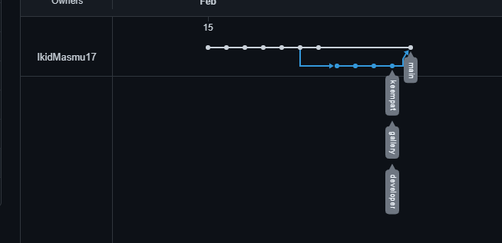

https://github.com/IkidMasmu17/altterraprojekUIUX